# Exercises: Git and GitHub - Teamwork

Problems for exercises and homework for the [“Software Technologies” course @ SoftUni](https://softuni.bg/courses/software-technologies).

## I. Introduction

We are going to practice using git in teams. Use Git Bash or Tortoise Git.

## II. Check your team and Choose Team Leader

Go to <https://js-teamwork.github.io/> and sign-in with your username, to see your teammates. Try connecting them /Facebook, email/;

When you manage to connect, choose a Team Leader. Remember, that the Team Leader is responsible for the failures and successes of the whole team. Choose wisely.

## III. Create Organization and Repository

The Team Lead should create an organization, you can call your Organization whatever you want, choose your Team Name wisely. This organization will represent your teamwork skills and your responsibility and serious attitude.

### Team Leader responsibilities:

#### Create the Organization and Invite all the members to join.

You can do this through your profile in GitHub. Just click the “+” sign next to your profile picture in the navigation bar.

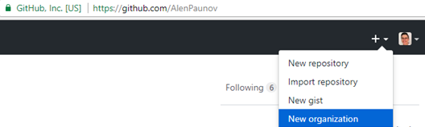

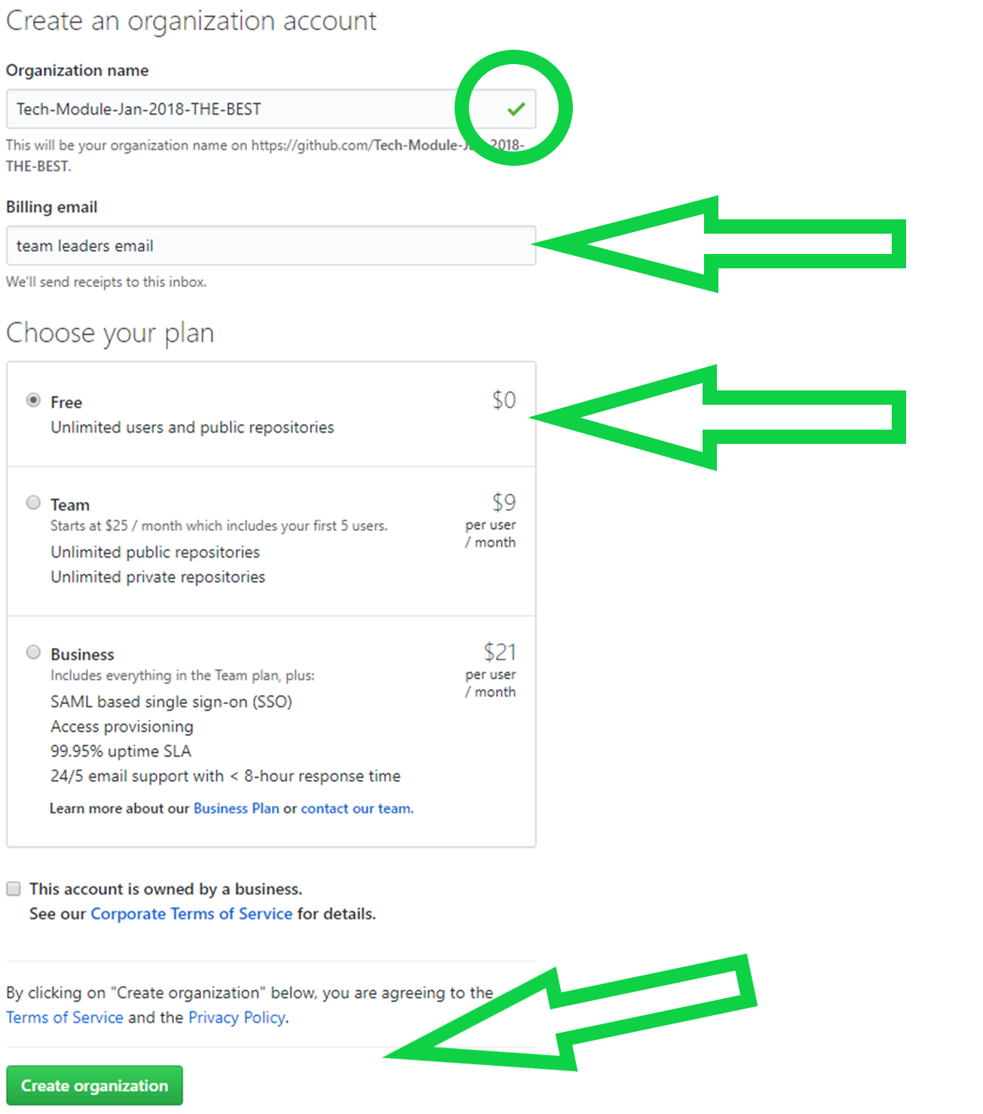

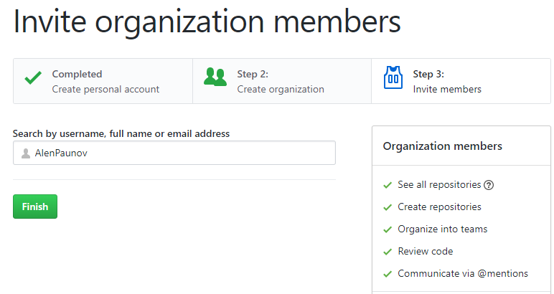

#### Create the Repository and add folder structure

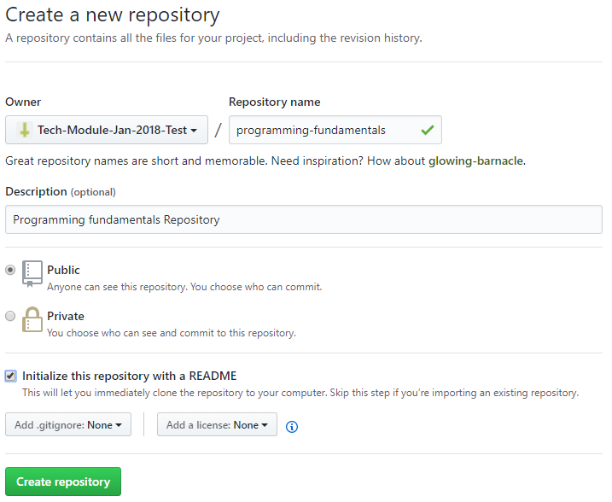

Clone the created Repository to your local machine and create folder called “intro-and-basic-syntax”. In this folder create a folder called “exercise”. In exercise folder put the file of your solution for Problem № 1 from the exercise <https://judge.softuni.bg/Contests/577> /you can submit code in **JAVA, C#, JavaScript and even Python or PHP**/;

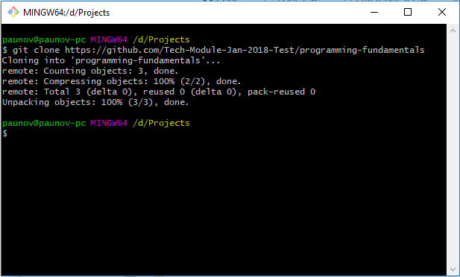

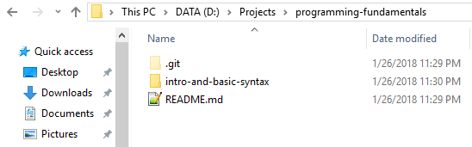

**Add** the file, **commit** the changes to your local repository and **push** them to the remote repository.

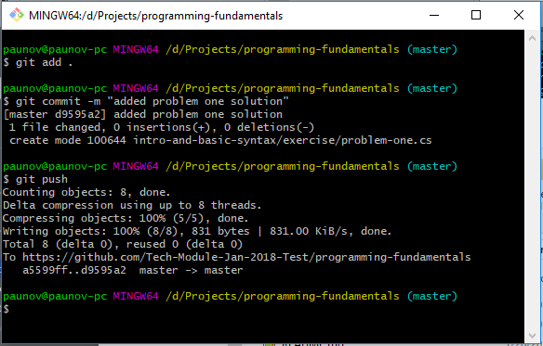

### Members responsibilities:

**Each Member**, including the Team Leader should clone the repository and:

#### Add a solution for a problem from the exercise:

**Drago** adds solution for **Problem 1** /already added/;

**Kosta** adds solution for **Problem 2**;

**Cveti** adds solution for **Problem 3;**

**Sisi** adds solution for **Problem 4**;

**Drago** adds solution for **Problem 5**;

#### Document the code of the NEXT Problem:

**Drago** documents the code of Solution of **Problem 2**;

**Kosta** documents the code of Solution of **Problem 3**;

**Cveti** documents the code of Solution of **Problem 4**;

**Sisi** documents the code of Solution of **Problem 5**;

**Drago** documents the code of Solution of **Problem 1**;

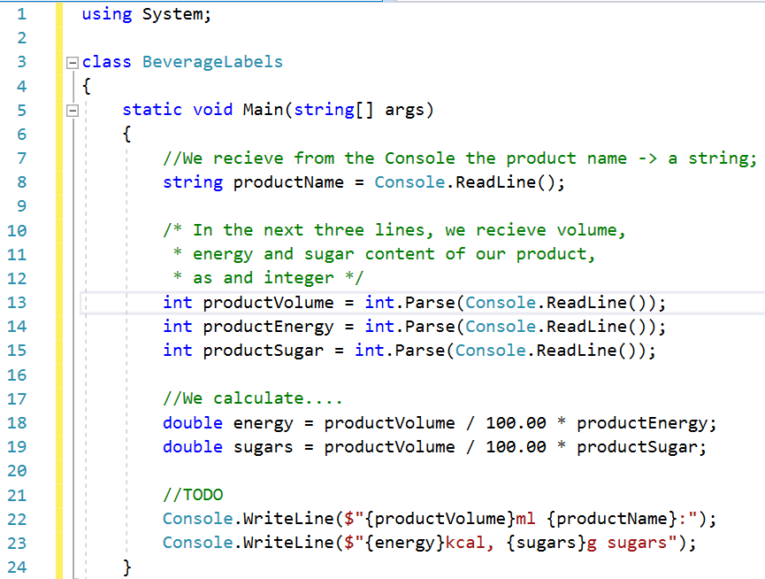

#### Add description in README.md for the NEXT problem:

* **Drago** adds description of **Problem 3**;
* **Kosta** adds description of **Problem 4**;
* **Cveti** adds description of **Problem 5**;
* **Sisi** adds description of **Problem 1**;
* **Drago** adds description of **Problem 2**;

You can use [text-to-markdown-converter](http://markitdown.medusis.com/)

You can learn more about Markdown language [here](https://en.wikipedia.org/wiki/Markdown).

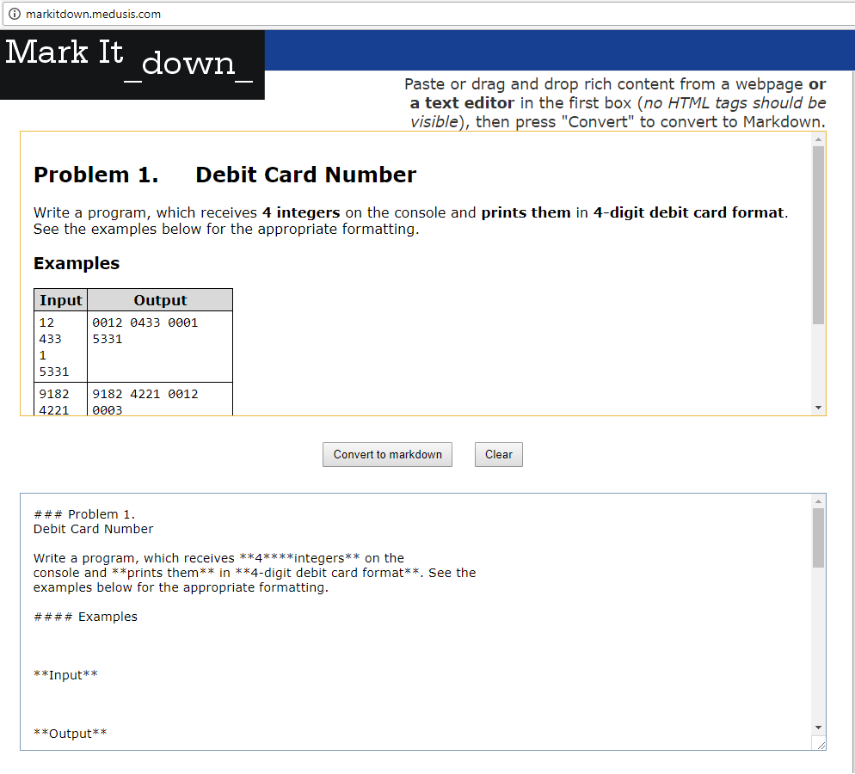

#### Change a variable name in the NEXT Problem:

* **Drago** changes variable name in **Problem 4**;
* **Kosta** changes variable name in **Problem 5**;
* **Cveti** changes variable name in **Problem 1**;
* **Sisi** changes variable name in **Problem 2**;
* **Drago** changes variable name in **Problem 3**;

#### Check the solution of NEXT Problem.

* **Drago** checks **Problem 5**;
* **Kosta** checks **Problem 1**;
* **Cveti** checks **Problem 2**;
* **Sisi** checks **Problem 3**;
* **Drago** checks **Problem 4**;

##### If there is a Problem with the code /wrong answer or spaghetti code :D/ Create new Issue in the Repository and Explain the problem for the member, who created the code.

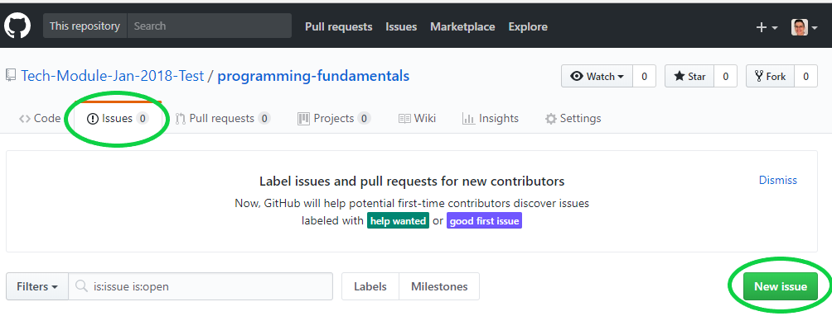

Add as **much details**, as possible. You can add steps to reproduce the bug or screenshots of the problem.

The process of submitting Issues is **major** part of our work as developers, working in a team. We should help each other. You should provide full info. It is recommended to give your opinion and proposal to resolve the problem.

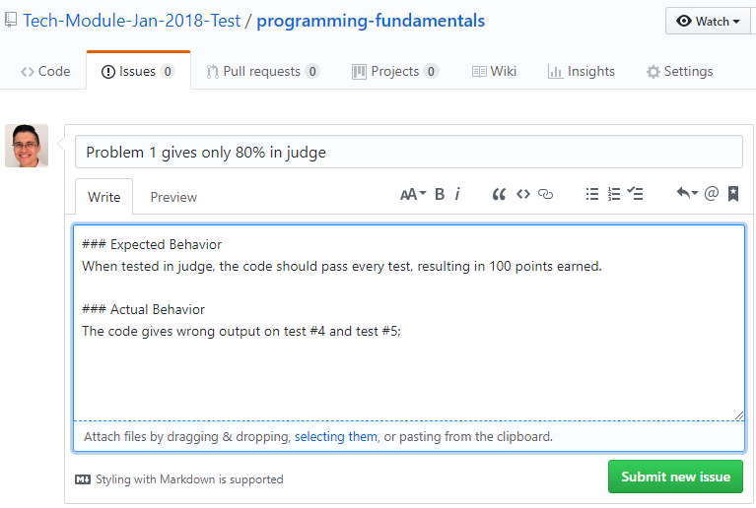

##### If there are no problems, add a line on top of the code “//CONFIRMED from” and your userName;

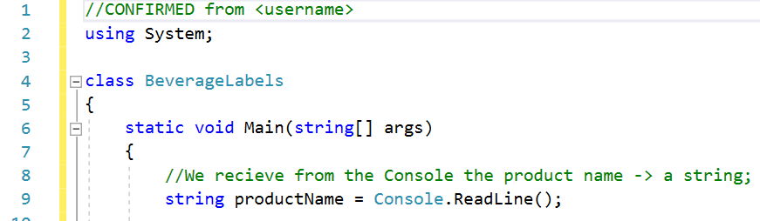

## IV. Create team.txt

Add a txt file containing all usernames of your team members and their softuni usernames each on a new line in the following format: “{github username} – {softuni username}”

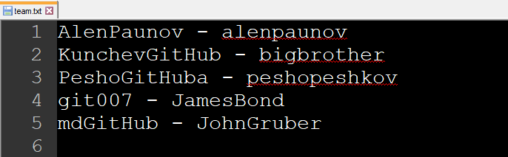

**Watch out because if you write the usernames wrong, your homework could not be checked and you will receive no bonus points.**

## V. Overview

Your repository should look something like this:

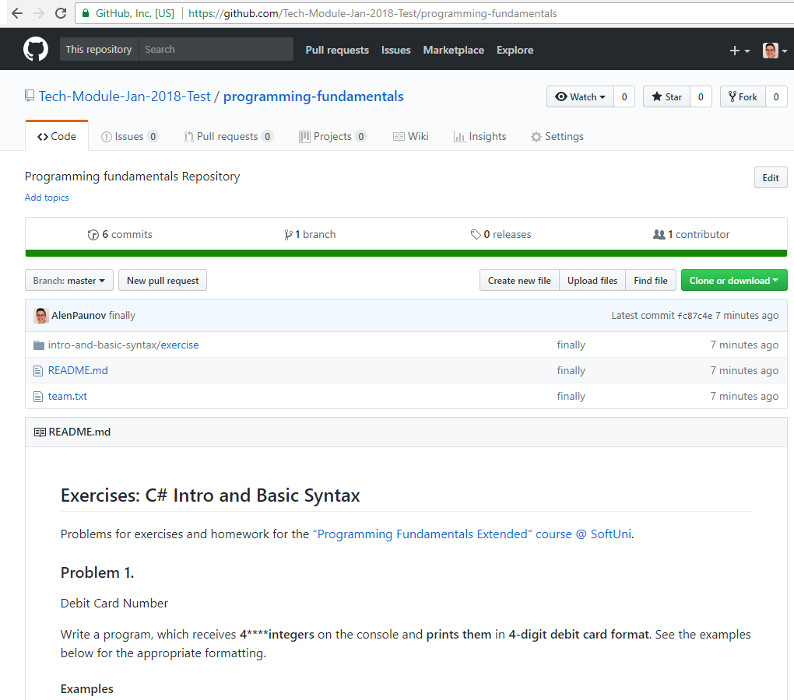

## VI. Submit your Homework

EACH Member should submit URL to the repository in homework section in softuni.bg. Create a .txt file:

On the first line paste the URL to the repository and on the second add your GitHub username.

After that zip the file and upload it in the homework submission area in softuni.bg.